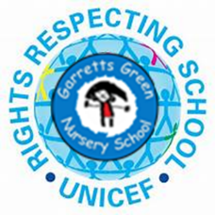

Dear Parent, Carer and Guardians,
During induction to Nursery we spoke about Garretts Green Nursery School & Enhanced Provision being a Rights Respecting School here is a little more information.
We are a Unicef UK Rights Respecting School! Silver award - Rights Aware
Garretts Green Nursery School & Enhanced provision are proud to have been awarded the Silver Rights Respecting Award in July 2023. This means that good progress towards embedding children’s rights in our school’s policy, practice and ethos, as outlined in the RRSA Strands and Outcomes has been achieved. We are now on our journey to achieving Gold. As a school we aim to be a place where children’s rights are at the heart of our ethos and culture, to empower children to protect themselves, improve well-being and to develop every child’s talents and abilities to their full potential.
Unicef is the world’s leading organisation working for children and young people and their rights. In 1989, governments across the world agreed that all children have the same rights by adopting the UN Convention on the Rights of the Child (UNCRC). These rights are based on what a child needs to survive, grow, participate and fulfil their potential.
The children will learn about their rights by putting them into practice every day and also through specific activities and projects. A Rights Respecting School models rights and respect in all its relationships. I have included our school charters which are the main articles (rights) from the convention that we concentrate on as school.
We really hope that you will be able to support our school in continuing our Rights Respecting Schools journey.
For further information about Rights Respecting Schools please visit: https://www.unicef.org.uk/rights-respecting-schools/about-us-new/
More information and exciting updates will follow soon.
Thank you,
Emma

